**Ideation Phase**

**Define the Problem Statements**

|  |  |
| --- | --- |
| Date | 19 September 2022 |
| Team ID | PNT2022TMID13339 |
| Project Name | Project - Smart Fashion Recommender Application |
| Maximum Marks | 2 Marks |

**Customer Problem Statement:**

**Smart Fashion Recommender Application:**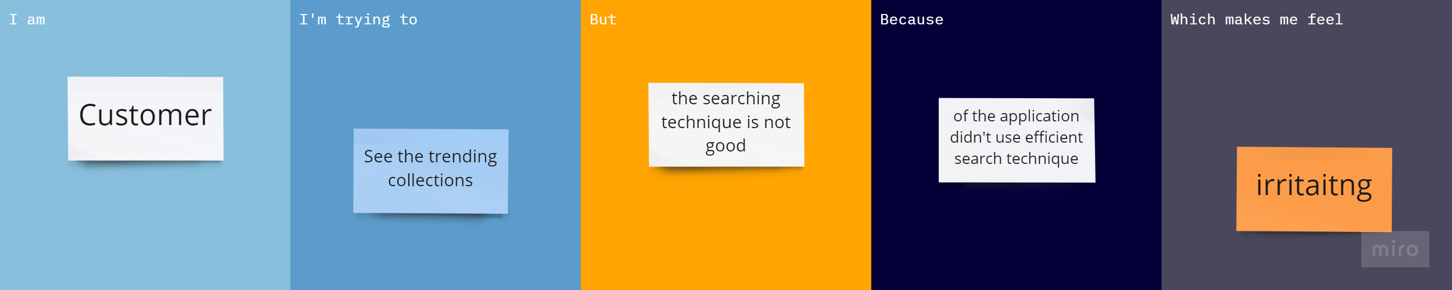

|  |  |  |  |  |  |
| --- | --- | --- | --- | --- | --- |
| **Problem Statement (PS)** | **I am** | **I’m trying to** | **But** | **Because** | **Which makes me feel** |
| PS-1 | customer | See the trending collections | The searching technique is not good | Of the app didn’t use efficient search technique | Irritating |
| PS-2 | customer | Explore the application | The UI is not good when I try to access through mobile | The design of UI is not reliable and the back-end is also bad | Frustrated |